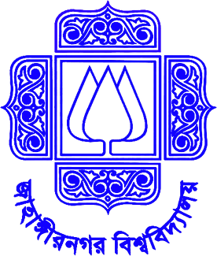

**DEPARTMENT OF COMPUTER SCIENCE & ENGINEERING**

**JAHANGIRNAGAR UNIVERSITY**

**Lab Assignment-02**

**Course Code: CSE-456**

**Course Title:** **Multimedia & Animation Techniques Laboratory**

**Submitted By:**

**Most. Laila Alam Luva**

**Class Roll: 359**

**Bsc(Hons) 4th year 2nd Semester**

**Dept. of CSE, Jahangirnagar University**

**Submitted to:**

[**Dr. Mohammad Zahidur Rahman**](https://www.juniv.edu/teachers/rmzahid)

###### **Professor**

**Dept. of CSE, Jahangirnagar University**

**Submission Date: 10.03.2021**

**Assignment No:** 02

**Assignment Name:** Developing new typefaces of the characters A & K

**Objectives:**

A typeface is a set of characters of the same design. These characters include letters, numbers, punctuation marks, and symbols. A typeface is the design of lettering that can include variations, such as extra bold, bold, regular, light, italic, condensed, extended, etc. Here is also to design serif and sans serif font of letter A & K. Serif is a decorative stroke that finishes off the end of a letters stem while a sans serif is a font that does not.

**Necessary Tools:**

1. FontForge (Font Editing tool)

**Procedure:**

1. Firstly we need to open the FontForge Software.
2. Then from the top bar we need to click

**Encoding option-> Force Encoding**.

1. As these are Unicode (A, K), so we need to select **ISO 10646-1(UNICODE-BMP).**
2. Then we need to search the Unicode selected for A and the Unicode selected for K .The Unicode for A is **“0985”** and for K is **“0995”.**
3. I have firstly tried to draw the in normal page to make the font as I want.
4. Then after clicking 0985 Unicode the letter can be drawn in the given window space. So here is given some tools like pen, point giving tool for drawing the font. And the pointer tool for editing or finishing for the exact font.
5. Then it’s the turn to save it.
6. Then after clicking 0995 the 5th number process should be continued.
7. Again we need to save this font.

10. According to these procedure serif, sans serif font of letter A & K

Should be drawn.

**Required Time:**

**For A:** Firstly I have made the typeface for A. As this is very new to me. So it took much time. Two days I have seen the video first related to this topic. Then I have started to draw. I have done this work slowly so the finishing may remain well. And finally after three more days I completed to draw serif font, sans serif font of A.

**For K:** After finishing the work of making the font for A I have started to draw K.As I got familiar with the tools at the time of designing A .So it took about 2 days to design the serif and sans serif font for K .

**Github link:** https://github.com/lailaalam/Multimedia-Labtask-Lab-2-